Father of Federation
Source 1
‘Federated Australia’ drawing, 1900
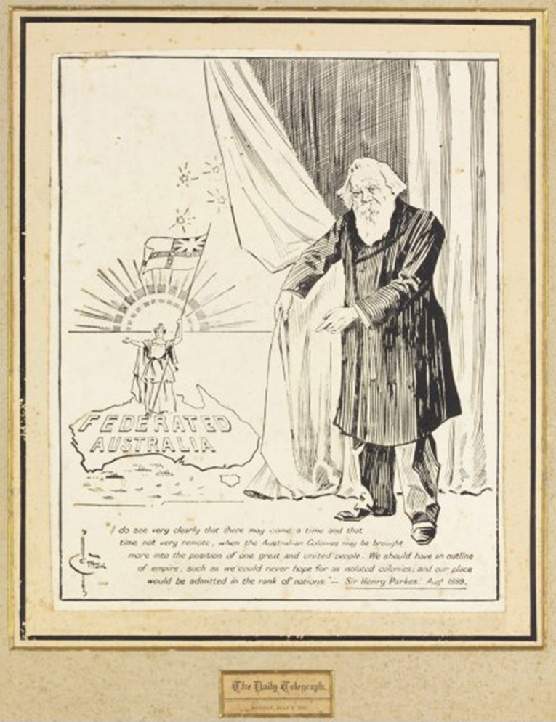
Cotton, H., ‘Federated Australia’ drawing, 1900 (TLF R8045), Daily Telegraph, Sydney, 1900, National Library of Australia number nla.pic-an6222063
Context of Source 1: This is a black-and-white pen-and-ink drawing by cartoonist and illustrator Herbert Cotton from 1900, of the New South Wales politician, Sir Henry Parkes, which appeared in the Daily Telegraph. Beneath the drawing is a quote from Parkes in 1889, in which he speaks of a vision for a federation of the Australian colonies.
‘I do see very clearly that there may come a time and that time not very remote, when the Australian Colonies may be brought more into the position of one great and united people. We should have an outline of empire, such as we could never hope for as isolated colonies, and our place would be admitted in the rank of nations — Sir Henry Parkes. August 1889

- In what kind of publication did this illustration appear? (Hint: check beneath the illustration)
- Describe what you see in this picture. Make sure you include as much detail as possible.
- Choose three of the sections of the picture you described in question 2 and explain what each of these means.
- What seems to be the artist’s point of view about Henry Parkes’s role in Federation?
- How does the quote beneath the picture illustrate that Henry Parkes had a great vision (idea of future greatness) for Australia? Refer to words or phrases in the quote to support your response.
- What did the artist hope to achieve by producing this illustration (his purpose)? Refer to visual and language features to support your response.
Source 2
Henry Parkes’s key arguments for Federation
Henry Parkes argued that Australia needed:
- a national defence force to protect the borders from foreign attack
- a central government with executive powers to control the defence force and make decisions without the involvement of Great Britain
- a uniform rail gauge to aid the movement of the national defence around the country.
He also argued that:
- America had between three and four million people when it became a Federation and gained independence from Britain. America achieved Federation through war.
- Australia had around three and a half million people by the 1880s and surely could achieve Federation and independence from Britain through peaceful means, not war.
- Each of the separate colonies should send a representation (delegate) to attend a convention to write a constitution for a Federal government.
- The delegates from the colonies should be appointed by Parliament to fully represent the different needs of each colony.
References:
Australian Dictionary of Biography [http:adb.anu.edu.au/biography/parkes-sir-henry-4366]
Constitution for a Nation [http://constitution.naa.gov.au/stories/call-to-action/pods/sir-henry-parkes-1890/index.html]
Sir Henry Parkes School of Arts [http:www.henryparkestenterfield.com/sir-henry-parkes/henry-parkes-tenterfield-oration-1889]
Context of source 2: In 1889, Sir Henry Parkes delivered a speech in Tenterfield, New South Wales, that came to be known as the ‘Tenterfield Oration’. In the speech, he called for a Federal Convention to discuss the idea of a national government for Australia and outlined the key reasons why a federated Australia was necessary.

- What seems to have been Parkes’s main reason for wanting a united Australia, outlined in the first three dot points above?
- What aspect of America’s independence movement does Parkes want to avoid?
- Why might the ‘different needs of each colony’ (last dot point above) have made agreement on a constitution challenging?

